Supporting document 1

Risk and technical assessment report – Application A1113

Extension of Use of Propionates in Processed Meat

Executive summary
Food Standards Australia New Zealand (FSANZ) received an Application from Axiome Pty Ltd, on behalf of Kemin Industries (Asia) Pte Ltd, seeking approval to use propionates as anti-microbial preservatives in processed meat, poultry and game. Use of the term propionates in this document refers collectively to propionic acid (INS 280), sodium propionate (INS 281), potassium propionate (INS 282) and calcium propionate (INS 283). The justification for the Application is to have alternative anti-microbial preservatives to limit the growth of Listeria monocytogenes in processed meat, poultry and game.

The Applicant seeks approval for the use of propionates, under the conditions of good manufacturing practice (GMP), in the following food categories of the Australia New Zealand Food Standards Code (the Code):

(i) Processed meat, poultry and game products in whole cuts or pieces, and
(ii) Processed comminuted meat, poultry and game products.

Propionates are currently listed for use under the conditions of GMP in these two food categories in the Codex General Standard for Food Additives (GSFA).

In the Code, all four propionates are currently permitted to be added to breads and bakery products, and flour products (including noodles and pasta). In addition, propionic acid, sodium propionate and calcium propionate are permitted in a number of other foods categories.

Propionic acid is a normal intermediary metabolite in humans and is naturally present in a wide variety of foods. Propionic acid and its sodium, calcium and potassium salts have a long history of use as food additives. Assessments by the Joint FAO/WHO Expert Committee on Food Additives (JECFA) and the European Food Safety Authority (EFSA) have concluded that there is no evidence of systemic toxicity resulting from oral exposure to propionates. Establishment of an ADI expressed in numerical form was therefore not deemed necessary by JECFA and EFSA. Because there is no evidence of systemic toxicity resulting from oral exposure to propionates, a dietary exposure assessment was not conducted for this Application.

Evidence submitted in support of this Application provides adequate assurance that propionates fulfil the stated technological function as anti-microbial food additives in processed meat, poultry and game. Any additional dietary exposure to propionates resulting from their use as food additives in processed meat, poultry and game products presents no identifiable public health and safety concerns.

Table of contents

Executive summary i
1 Introduction 2
1.1 Objectives of the risk and technical assessment 2
2 Food technology assessment 2
2.1 Introduction and description of substance 2
2.1.1 Identity 3
2.1.2 Technological purpose 3
2.1.3 Technological justification 3
2.2 Chemical properties 5
2.2.1 Chemical names and structures 5
2.3 Analytical method for detection 6
2.4 Manufacturing process 7
2.4.1 Propionic Acid 7
2.4.2 Sodium propionate, calcium propionate and potassium propionates 7
2.5 Product specifications 7
2.5.1 Stability 10
2.6 Evaluation of efficacy 10
2.6.1 Listeria monocytogenes 10
2.6.2 Challenge studies to demonstrate efficacy 10
2.7 Technical and Efficacy Conclusion 12
3 Hazard Assessment 12
4 Dietary Exposure Assessment 13
5 Risk Characterisation 13
6 Risk and technical assessment conclusions 13
6.1 Reponses to risk and technical assessment questions 13
7 References 15

1 Introduction
Food Standards Australia New Zealand (FSANZ) received an Application from Axiome Pty Ltd, on behalf of Kemin Industries (Asia) Pte Ltd, seeking approval to use propionates as anti-microbial preservatives in processed meat, poultry and game products. The term propionates is used in this document to refer collectively to propionic acid (INS 280), sodium propionate (INS 281), potassium propionate (INS 282) and calcium propionate (INS 283). The justification for the Application is to have alternative anti-microbial preservatives to limit the growth of Listeria monocytogenes in processed meat, poultry and game products.
The Applicant seeks approval for the use of propionates, under the conditions of GMP, in the following food categories:

(i) Processed meat, poultry and game products in whole cuts or pieces, and
(ii) Processed comminuted meat, poultry and game products.

Propionates are listed under these two food categories in the Codex General Standard for Food Additives (GSFA), for use under the conditions of GMP.

In the Australia New Zealand Food Standards Code (the Code), all four propionates are currently permitted to be added to breads and bakery products (at a maximum permitted level, MPL, of 4000 mg/kg) and flour products, including noodles and pasta (MPL 2000 mg/kg). Sodium propionate and calcium propionate are also permitted in a number of other foods categories, namely oil emulsions (under the conditions of GMP), fruit and vegetable spreads including jams, chutneys and related products (GMP), fruit and vegetable juices and fruit and vegetable juice products (GMP), formulated beverages (GMP), and sauces and toppings, including mayonnaises and salad dressings (GMP). Propionic acid, sodium propionate and calcium propionate are permitted to be added to solid formulated supplementary sports foods at an MPL of 400 mg/kg.

1.1 Objectives of the risk and technical assessment
The objectives of this risk and technical assessment are to assess whether the addition of propionates to processed meat, poultry and game products is technologically justified and whether addition of propionates added to processed meat, poultry and game products presents any public health and safety concerns. The following key questions have been posed:

1. Do propionates achieve their stated technological function in the form and quantity used as food additives in processed meat, poultry and game products?

2. Are there any public health and safety concerns associated with the use of propionates as food additives in processed meat, poultry and game products?

2 Food technology assessment

2.1 Introduction and description of substance
Propionic acid and its calcium, sodium and potassium salts, collectively known as “propionates”, exert antimicrobial activity against mould and a few bacteria. Propionic acid has found extensive use in the bakery field where it inhibits mould and the bacterium Bacillus mesentericu, the spores of which can survive the baking process. Propionates are also particularly effective in inhibiting L. monocytogenes at the pH level associated with comminuted meat, poultry and game that receive no further heat treatment prior to consumption by the consumer. Propionates can be used at low concentrations to prevent growth of L. monocytogenes and have the advantage of not imparting any flavour on the product. When used in combination with nitrite/nitrate they can provide control against a broader range of microorganisms and potentially result in reduced nitrite/nitrate use levels.

Propionates naturally occur in foods such as butter, cheese and other dairy foods and have been used as food preservatives widely for more than 60 years. The safety of propionates has been reviewed by the Joint FAO/WHO Expert Committee on Food Additives (JECFA), the European Food Safety Authority (EFSA) and the US Food and Drug Administration (US FDA) and all of these agency reviews have confirmed or reconfirmed that there are no safety concerns in respect to the use of propionates as preservatives in the currently permitted uses and usage levels.

Current permissions for propionates in the Code are described in Section 1. CODEX permits propionates in Food Categories 08.2 (Processed meat, poultry, and game products in whole pieces or cuts) and 08.3 (Processed comminuted meat, poultry, and game products), under the conditions of GMP. In the USA; sodium propionate and propionic acid are permitted in ready to eat meat and poultry, where antimicrobials are permitted, up to 0.5% by weight.

The purpose of this application is to request permission for the extension of use of propionates in processed meat, poultry and game products in whole cuts or pieces and processed comminuted meat, poultry and game products. The permission sought is for use at a maximum level necessary to achieve one or more technological purposes under the conditions of GMP. Typical use levels range from 0.1 – 0.25% as propionic acid on food product weight basis.

2.1.1 Identity
Propionates are approved as preservatives for use in certain foods in the Code. Their purity for use and hence the level and type of impurities is controlled by the requirements of Standard 1.3.4 Identity and Purity, which references JECFA Food Additive Specifications as one of the primary specification sources (section 4.2).

2.1.2 Technological purpose
The technological purpose of propionates, with reference to S-14 of the Code is as anti-microbial preservatives.

2.1.3 Technological justification
This application is specifically focused on the control of L. monocytogenes contamination in processed meat, poultry and game products or in whole pieces or cuts and processed comminuted meat, poultry and game products.

FSANZ Australian food recall statistics 2005 to 2014, provided by the Applicant to support the technical justification for using propionates, identify microbial contamination as the principal recall reason (33% of all recalls) which is typically the case for each year of data. For all microorganisms associated with microbial contamination recalls, L. monocytogenes is reported as the most common causal organism (45% of all microorganisms). For recalls involving meat, including poultry, the most common food category (49% of all recalls) was due to L. monocytogenes contamination (Figure 1).

Number of recalls
E.coli
29 recalls in total
Salmonella
38 recalls in total
L. monocytogenes
88 recalls in total

Figure 1: Type of food products recalled by FSANZ 1 January 2005 to 31 December 2014 due to microbiological contamination (Australian recalls).

Propionates have been demonstrated to be particularly effective for inhibiting growth of L. monocytogenes in processed meat, poultry and game (at low usage levels and without effect on product quality), either singly or in combination with other preservatives for synergistic effect. The mechanism for antimicrobial activity, as with other lipophilic organic acids, is thought to be that they inhibit or kill microorganisms by interfering with the permeability of the microbial cell membrane, thus disrupting important metabolic processes. The undissociated form of the lipophilic acid is required for antimicrobial activity. Thus inhibitory potency, together with other factors, is linked to pKa value (propionic acid has a pKa value of 4.87). Compared to other organic acids such as lactic acid (pKa 3.83), the higher pKa value of propionic acid requires lower levels to achieve the same antimicrobial potency.

Data presented from two published challenge studies (Glass et al 2013, 2007) by the Applicant and assessed by FSANZ (see section 2.7), demonstrates the efficacy of sodium propionate, at a range of concentrations and temperature regimes, as a preservative to inhibit the growth of L. monocytogenes in:

- cured deli-style turkey and ham and uncured turkey
- meat preparations where sodium solution was incorporated into the brine solution
- sliced cooked meat by surface inoculated between

FSANZ deems the range of meat, poultry and game assessed to be sufficient to demonstrate efficacy in a variety of processed meat, poultry and game concordant with the permission being sought i.e. for use in processed comminuted meat, poultry and game products and processed meat, poultry and game products in whole cuts or pieces.

2.2 Chemical properties

2.2.1 Chemical names and structures

2.2.1.1 Propionic acid
Common names: Propanoic acid; Ethylformic acid; Methylacetic acid
Carboxyethane; Ethanecarboxylic acid.
INS No.: 280
Chemical name: Propionic acid
C.A.S. number: 79-09-4
Chemical formula: C3H6O2
Molecular weight: 74.08
Propionic acid is miscible with water and ethanol.

Structural formula:
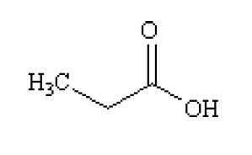

2.2.1.2 Sodium propionate
Common names: Sodium propanoate; Sodium dipropionate; Sodium ethanecarboxylate; Napropion; Propionic acid, sodium salt; Propanoic acid, sodium salt; Propanoic acid, sodium salt (1:1).
INS No.: 281
Chemical name: Sodium propionate
C.A.S. number: 137-40-6
Chemical formula: C3H5NaO2
Molecular weight: 96.06
Sodium propionate is freely soluble in water and ethanol

Structural formula:

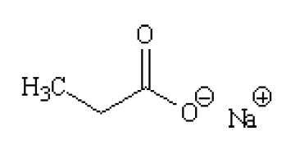

2.2.1.3 Calcium propionate
Common names: Calcium propanoate; Mycoban; Calcium dipropionate; Bioban-C; Propionic acid, calcium salt; Propanoic acid, calcium salt; Propanoic acid, calcium salt (2:1).
INS No.: 282
Chemical name: Calcium propionate
C.A.S. number: 4075-81-4
Chemical formula: C6H10CaO4
Molecular weight: 186.22
Calcium propionate is freely soluble in water and ethanol.

Structural formula:

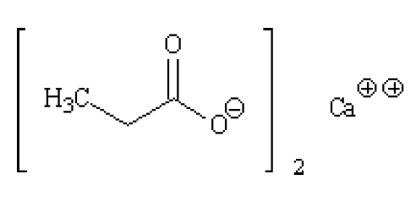

2.2.1.4 Potassium propionate
Common names: Potassium propanoate; Potassium propionate; Propionic acid, potassium salt; Propanoic acid potassium salt; Propanoic acid, potassium salt (1:1)
INS No.: 283
Chemical name: Potassium propionate
C.A.S. number: 327-62-8
Chemical formula: C3H5KO2
Molecular weight: 12.17
Potassium propionate is freely soluble in water and soluble in ethanol (JECFA, 2006).

Structural formula:

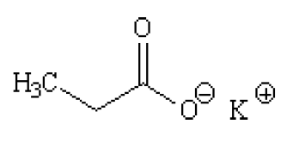

2.3 Analytical method for detection
Numerous methods for the determination of propionates in food have been referenced by the Applicant and are included in section 7 below. It is noted that the foods referenced are bread and bakery products rather than processed meat, the food group which is the focus of the application.

FSANZ sought advice from the Implementation Subcommittee for Food Regulation (ISFR) Expert Advisory Group (EAG) on analytical methods regarding the suitability of analytical methods relevant to this Application. The ISFR EAG stated “that there are appropriate methods available for the determination of propionic acid in processed meats”.

2.4 Manufacturing process

2.4.1 Propionic Acid
Although numerous fermentation processes have been identified and evaluated, the industrial production of propionic acid is almost entirely by chemical synthesis (petrochemical route). The acid can also be obtained from oxidation of propionaldehyde and very pure propionic acid can be obtained from propionitrile. The main (synthetic) processes include the Reppe process where ethylene is reacted with carbon monoxide and steam (synthesis gas) in the presence of a nickel catalyst, to produce propionaldehyde, which is then oxidised to propionic acid, and the Larson process from ethanol and carbon monoxide using boron trifluoride as a catalyst. It is also obtained by oxidation of propionaldehyde, as a by-product in the Fischer-Tropsch process for the synthesis of fuel and in wood distillation as a by-product of the pyrolysis.

2.4.2 Sodium propionate, calcium propionate and potassium propionates
Calcium, potassium and sodium propionates are produced by the reaction of propionic acid with the respective hydroxides or carbonates:

- Sodium propionate is produced from propionic acid and sodium hydroxide in hydrogen peroxide and water.
- Calcium propionate is produced by the reaction of propionic acid and calcium oxide in water in the presence of a flocculent.

In both instances following the reaction, the products are filtered, spray dried, sieved and packed.
For potassium propionate, no description of manufacturing methods was readily retrievable.

2.5 Product specifications
For the specifications for the propionates, the Applicant has referred to the specifications of propionic acid (E 280), sodium propionate (E 281), calcium propionate (E 282) and potassium propionate (E 283) which have been defined in Commission Regulation (EU) No 231/2012 and by JECFA (2006) (Tables 1- 4).

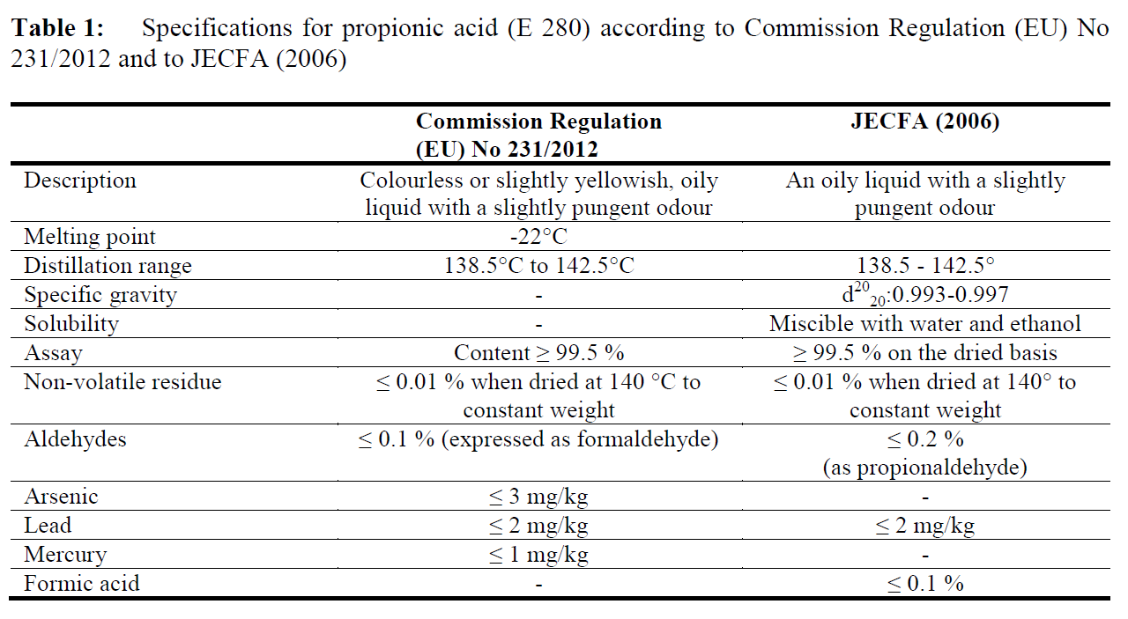
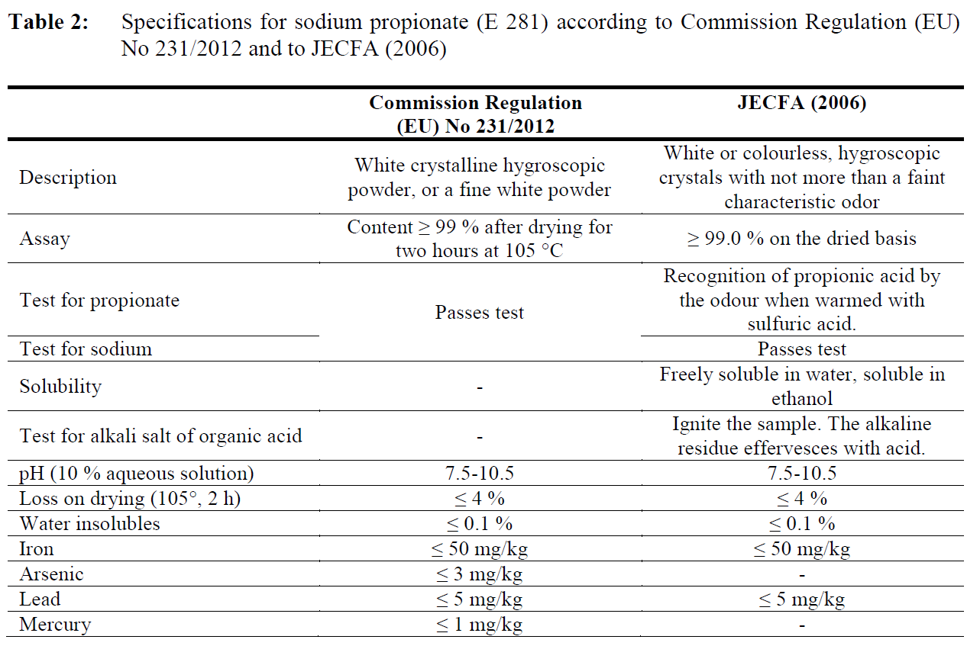

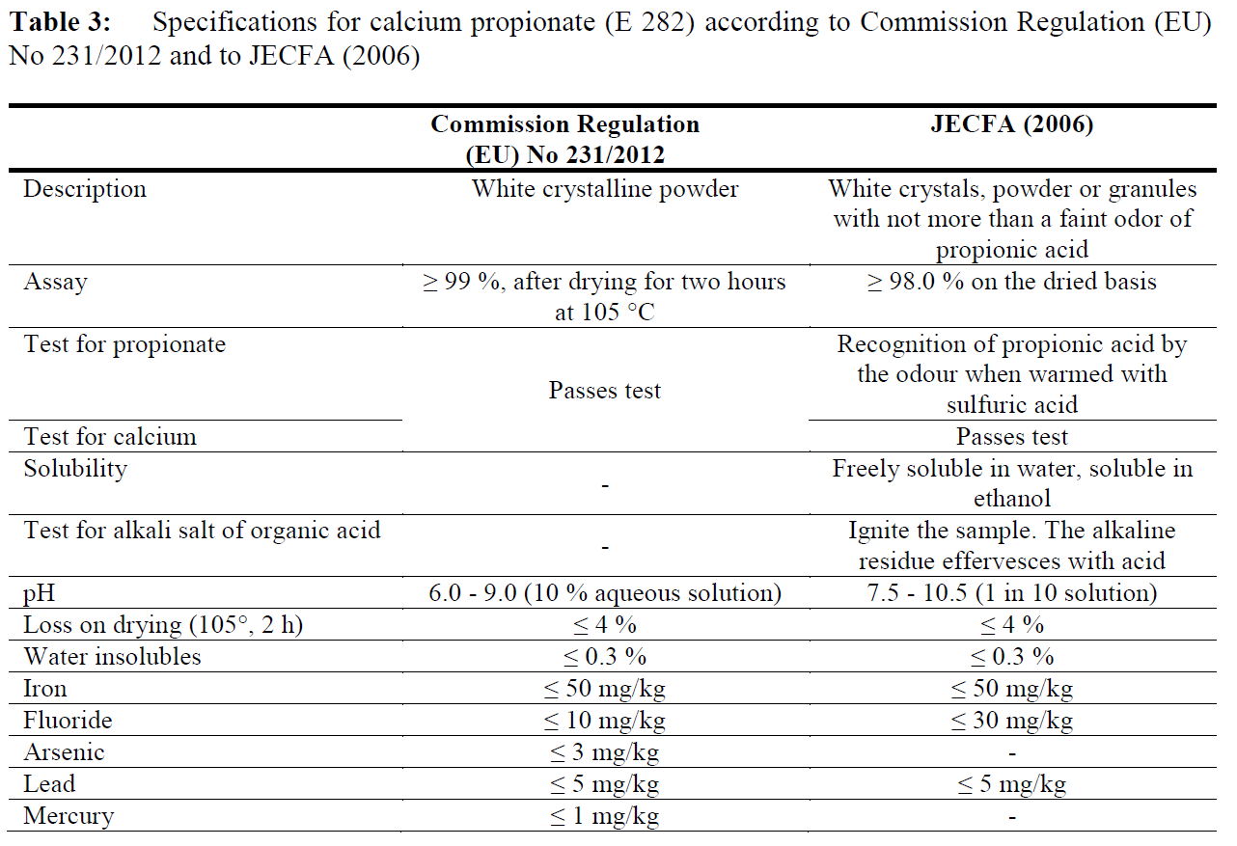
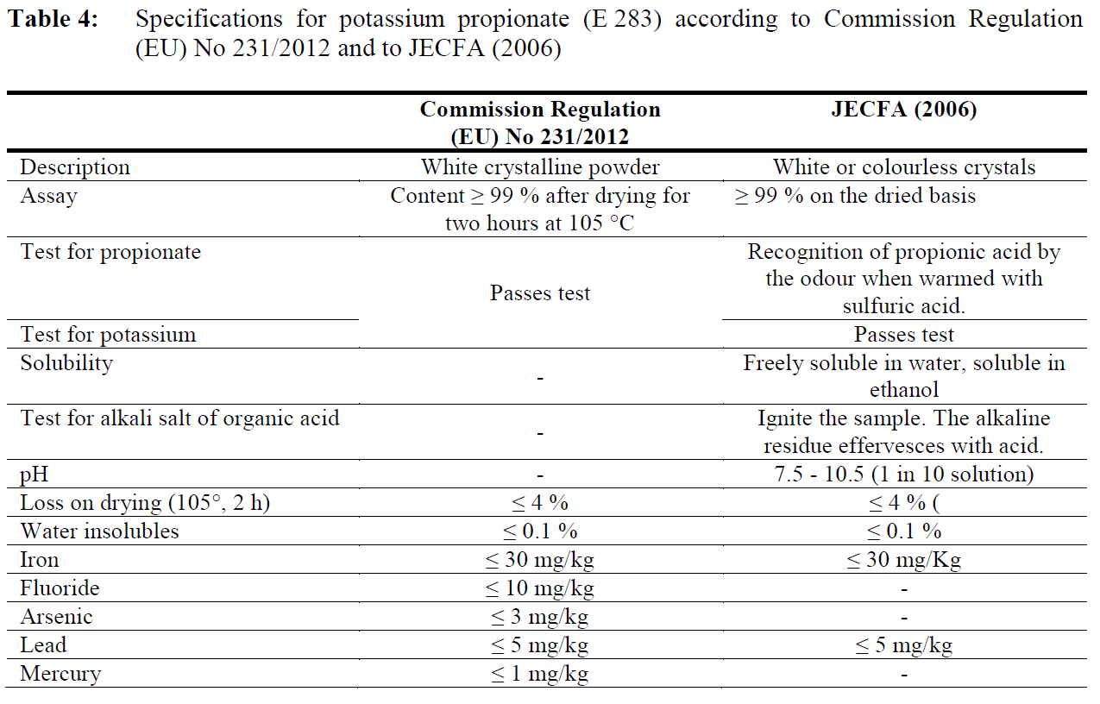

It is noted in table 3 that the pH range in the EU specifications (6.0 - 9.0 of a 10 % solution of calcium propionate) and the JECFA specifications (7.5 -10.5) are different. According to the Food Chemical Codex (FCC, 2010-2011) the pH of a 10 % aqueous solution of calcium propionate is between 7.5 and 10.5. It is not necessary to further address this difference in pH. The reference to either of the JECFA or FCC specifications is acceptable for calcium propionate.

Specifications for propionates are adequately covered by existing references.

2.5.1 Stability
No data have been found in relation to reaction and fate in food of propionic acid and its salts as food additives, however, information provided by industry during the EFSA re-evaluation of propionic acid – propionates (E 280-283), indicated that the stability of sodium or calcium propionate in their original packaging is 3 years.

2.6 Evaluation of efficacy
The Applicant seeks an extension of use of propionic acid, and its calcium, potassium and sodium salts, as anti-microbial preservatives in processed meat, poultry and game. The principal justification for seeking an extension of use in processed meat, poultry and game is to inhibit the growth of L. monocytogenes. The efficacy of propionates to prevent the growth of L. monocytogenes in a variety of processed meat, poultry and game was considered.

2.6.1 Listeria monocytogenes
L. monocytogenes causes invasive listeriosis, a disease that can have severe consequences for particular groups of the population. Listeriosis most often affects individuals experiencing immunosuppression, including those with chronic disease (e.g. cancer, diabetes, malnutrition, AIDS), foetuses or neonates (assumed to be infected in utero); the elderly and individuals being treated with immunosuppressive drugs (e.g. transplant patients). Manifestations of the disease include, but are not limited to, bacteraemia, septicaemia, meningitis, encephalitis, miscarriage, neonatal disease, premature birth, and stillbirth (Codex 2007). In otherwise healthy individuals, infection with L. monocytogenes is usually non-invasive, causing few or no symptoms and may be mistaken for mild gastroenteritis or flu.

L. monocytogenes grows at low oxygen conditions and refrigeration temperatures (<4° C), and can survive for long periods in the environment, on foods, in the processing plant and in the household refrigerator. Foods associated with causing listeriosis have been overwhelmingly ready-to-eat (RTE) products that are typically held for extended periods at refrigerated temperatures, in which L. monocytogenes can grow to levels that can present a risk to consumers (Codex 2007). Growth of L. monocytogenes does not occur in foods with pH <4.4, regardless of water activity; water activity <0.92, regardless of pH; or a combination of pH <5.0 and water activity <0.94 (Codex 2007). Data provided by the Applicant on the characteristics for various processed meat products have pH >5.5 and water activity > 0.95, characteristics which support the growth of L. monocytogenes in the absence of inhibitory substances.

2.6.2 Challenge studies to demonstrate efficacy
The Applicant provided data from two published challenge studies of sodium propionate in cured deli-style turkey (Glass et al 2013) and ham and uncured turkey (Glass et al 2007) to demonstrate the efficacy of sodium propionate to inhibit the growth of L. monocytogenes when stored at 4⁰ C and under temperature abuse conditions of 7 and 10⁰ C. Sodium propionate solution was incorporated into meat preparations with brine solution to achieve the target concentrations of propionate. Control product, without the addition of the sodium propionate treatment, was also processed concurrently with treated products. The cured deli-style turkey products were prepared, cooked, sliced, chilled and vacuum packaged at a commercial manufacturer under GMP before transport at 4⁰ C to the laboratory where the challenge studies were performed. The studies were replicated twice (Glass et al 2007; Glass et al 2013).

The challenge studies were performed on sliced cooked meat and surface inoculated between slices with 5 log cfu per 100g package with a five strain mixture of L. monocytogenes. Inoculated products were vacuum-packaged in gas-impermeable pouches and incubated at 4, 7 or 10⁰ C for 12 weeks. The strains used for the challenge experiments on cured deli-style turkey are described in Table 1 (Glass et al 2013). The challenge strains were the same for ham and uncured turkey with the exception of L. monocytogenes strain Scott A (clinical strain serotype 4b) being used instead of strain FSL-C1-109 (Glass et al 2007).

For cured deli-style turkey stored at 4⁰ C, growth inhibition of L. monocytogenes relative to the control was achieved for all concentrations of liquid sodium propionate tested (Table 2) and growth of L. monocytogenes was limited to an increase of <1-log for a minimum of nine weeks for all concentrations and samples tested for both replicate trials (Table 2). Populations of L. monocytogenes stored at 4⁰ C for 10 weeks and beyond demonstrated variability between samples within replicate trials, supporting ≥1-log increase in at least one sample each until week 12 (Glass et al 2013).

For ham and uncured turkey, growth inhibition of <1-log was achieved for the duration of the trial (12 weeks) for the highest concentrations of propionate, 0.20 and 0.30%. For ham and uncured turkey containing 0.10% propionate and stored at 4⁰ C, growth inhibition of <1-log was achieved for 10 and six weeks, respectively. For ham containing 0.05% propionate, growth inhibition was equivalent to the control (Glass et al 2007).

For the cured deli-style turkey stored under moderate temperature abuse conditions of 7⁰C, L. monocytogenes growth in the control exceeded 4-log after two weeks of storage. For cured deli-style turkey preparations containing 0.30% proprietary liquid sodium propionate solution, growth of L. monocytogenes was inhibited to <1-log after two weeks of storage and concentrations of 0.40 and 0.50% inhibited growth to <1-log after four and six weeks of storage, respectively at 7⁰ C.

For ham and uncured turkey containing ≥0.20% propionate, L. monocytogenes growth was delayed by four weeks at 7⁰ C and for ham containing 0.30% propionate; L. monocytogenes growth was delayed by four weeks at 10⁰ C. For the uncured turkey stored at 10⁰ C, none of the treatments delayed L. monocytogenes growth (Glass et al 2007).

Table 1: Strains of L. monocytogenes used in challenge studies to demonstrate efficacy of sodium propionate as a preservative in processed meat products
L. monocytogenes strain | Serotype | Source of strain
FSL-C1-109 | 4b | Deli turkey isolate associated with illness
LM 101 | 4b | Hard salami isolate
LM 108 | 1/2a | Hard salami isolate
LM 310 | 4 | Goats milk cheese isolate associated with illness
V7 | 1 | Unpasteurised milk isolate

Table 2: Inhibition of L. monocytogenes in high moisture processed meat products at different target concentrations of propionic acid
Processed meat type | Target propionate concentration  (%) | Mean pH ±SD | Moisture content (%) | Mean water activity ±SD | Duration of inhibiting growth to <1-log (weeks)
Cured deli-style turkey | Control  0.30†  0.40†  0.50† | 6.44±0.10  6.30±0.12  6.20±0.12  6.13±0.10 | 76.62±0.56  77.02±0.68  76.54±0.49  76.18±0.49 | 0.978±0.004  0.977±0.003  0.977±0.003  0.977±0.002 | <4  9  9  9
Uncured turkey | Control  0.10‡  0.20‡  0.30‡ | 6.42±0.10# | 75.04±1.08# | 0.972±0.001# | <2  6  12*  12*
Ham | Control  0.05‡  0.10‡  0.20‡  0.30‡ | 6.39±0.02# | 73.65±0.10# | 0.967±0.000# | 2  2  10  12*  12*
† Liquid sodium propionate concentration; ‡ propionate concentration; #Results are an average ± standard deviation for analysis of 16 antimicrobial formulations, including propionates, sorbates, benzoates, lactate-diacetate and combinations of antimicrobials; * duration of the study.

Additional challenge studies on a variety of processed meat products were provided to FSANZ containing commercial confidential information. FSANZ has assessed the studies and concludes that L. monocytogenes growth inhibition was achieved.

2.7 Technical and Efficacy Conclusion
Technologically, the use of propionates in processed meat, game products in whole meat cuts or pieces, processed comminuted meat, poultry and game products is justified. In liquid preparation for addition to processed meat, sodium propionate, calcium propionate and potassium propionate will be dissociated into the active propionate ion and their relevant cations. Data presented by the Applicant and assessed by FSANZ demonstrates the efficacy of propionic acid and its sodium, calcium and potassium salts at a range of concentrations, as a preservative to inhibit the growth of L. monocytogenes in processed meat products in the form and amounts proposed. FSANZ deems the range of meat products assessed to be sufficient to demonstrate efficacy in a variety of processed meat products.

3 Hazard Assessment
Propionic acid is a normal intermediary metabolite in humans and is naturally present in a wide variety of foods. The Joint FAO/WHO Expert Committee on Food Additives (JECFA) established an Acceptable Daily Intake (ADI) “not limited” for propionic acid and its sodium, calcium and potassium salts (WHO 1974). The term ADI “not limited” is no longer used by JECFA, however it has the same meaning as the current term ADI "not specified”, which is applicable to a food substance of very low toxicity for which the total dietary intake of the substance arising from its use at the levels necessary to achieve the desired effect and from its acceptable background levels in food, does not represent a hazard to health (WHO 2009). Establishment of an ADI expressed in numerical form was therefore not deemed necessary by JECFA. A subsequent evaluation by the European Scientific Committee on Food (SCF) concluded that there were no adverse health consequences to humans from the use of propionic acid as a food additive and established an ADI “not specified” (SCF 1992).

The European Food Safety Authority (EFSA) has recently re-evaluated propionic acid and its sodium, calcium and potassium salts (EFSA 2014). EFSA concluded that an ADI should not be established because no evidence of systemic toxicity has been observed in animal or humans studies. The only reported adverse effect attributable to exposure to propionates via the oral route was reversible epithelial hyperplasia of the oesophagus due to a local irritant effect at dietary concentrations of 10,000 mg/kg and greater.

4 Dietary Exposure Assessment
A dietary exposure assessment was not conducted because there is no evidence of systemic toxicity resulting from oral exposure to propionates, and therefore a numerical ADI has not been established. It is noted that the Application indicates that typical levels of addition of propionates to processed meat products are in the range of 0.1–0.25% w/w (1000–2500 mg/kg), which is lower than the highest existing MPL for propionates in the Code (4000 mg/kg for breads and bakery products). Levels as high as 6200 mg/kg have been reported to occur naturally in cheese (EFSA 2014).

5 Risk Characterisation
Propionic acid is a normal intermediary metabolite in humans and is naturally present in a wide variety of foods. Propionic acid and its sodium, calcium and potassium salts have a long history of use as food additives. Assessments by JECFA and EFSA have concluded that there is no evidence of systemic toxicity resulting from oral exposure to propionates. Any additional dietary exposure to propionates resulting from their use as food additives in processed meat products presents no identifiable public health and safety concerns.

6 Risk and technical assessment conclusions
This risk and technical assessment evaluated the technological suitability and safety of the proposed addition of propionates to processed meat products.

6.1 Reponses to risk and technical assessment questions
1. Do propionates achieve their stated technological function in the form and quantity used as food additives in processed meat products?

Section of report | Summary response/conclusion
Section 2 | Evidence submitted in support of this Application provides adequate assurance that propionates fulfil the stated technological function as anti-microbial preservatives to limit the growth of Listeria monocytogenes in processed meat products.

2. Are there any public health and safety concerns associated with the use of propionates as food additives in processed meat products?

Section of report | Summary response/conclusion
Section 3, 4 and 5 | There are no identifiable public health and safety concerns associated with the proposed use of propionates as food additives in processed meat products.

7 References
Methods for the determination of propionates in food, provided by Applicant:
- simplified technique for the determination of propionates in bread by isolation using micro-diffusion (Karasz and Hallenbeck, 1972)
- gas chromatographic method to determine the content of propionic acid in rye bread and margarine (Graveland, 1972)
- gas chromatographic determination of propionic acid in “sweet oven products” or prodotti dolciari al forno (Cuzzoni, 1964)
- gas chromatographic determination to determine the content of propionic acid in various types of bread and sourdough (Luck et al., 1975)
- isothermal gas chromatographic determination of the propionic acid after mechanical extraction from bread and cake (Isshiki et al., 1981)
- specific chromatographic method for the determination of propionate in white rye and whole grain bread (Lamkin et al., 1987)
- gas chromatographic determination of propionic acid and propionates in bakery products (Khaldun et al., 2010).
- method developed for the determination of eleven preservatives (including propionic acid) in food samples by GC-FIP (Gu et al., 2012).
- HPLC method (hydrogen ion exchange column) for the simultaneous determination of ten organic acids (including propionic acid) has been described (Chen et al., 2012).
- HPLC method for the quantitative determination of sodium propionate and calcium propionate in different foodstuff (cake, dry soybean, sausage, noodle, etc.) has been described (Liang, 2009)
- quantitative determination of sodium propionate and calcium propionate (transformed into propionic acid) in food has been reported by capillary gas chromatography (Gao and Zhao, 2012).
- a new method for the quantitative determination of calcium propionate in cakes by ion chromatography with suppressed conductivity detection has been investigated (Dai et al., 2013).

Commission Regulation (EU) specifications for propionic acid (E 280), sodium propionate (E 281), calcium propionate (E 282) and potassium propionate (E 283) ( No 231/2012).
Available at (L 83/87 – L 83/89): http://faolex.fao.org/docs/pdf/eur111209.pdf

JECFA specifications for propionic acid (E 280), sodium propionate (E 281), calcium propionate (E 282) and potassium propionate (E 283). JECFA (2006)
Propionic acid. Available at: http://www.fao.org/food/food-safety-quality/scientific-advice/jecfa/jecfa-additives/result/en/
Sodium propionate. Available at: http://www.fao.org/food/food-safety-quality/scientific-advice/jecfa/jecfa-additives/result/en/
Calcium propionate. Available at: http://www.fao.org/food/food-safety-quality/scientific-advice/jecfa/jecfa-additives/result/en/
Potassium propionate. Available at: http://www.fao.org/food/food-safety-quality/scientific-advice/jecfa/jecfa-additives/result/en/

Codex (2007) Guidelines on the Application of General Principals of Food Hygiene on the Control of Listeria monocytogenes in Foods (CAC/GL 61 - 2007). Codex Alimentarius Commission, Geneva, Switzerland. Available at: http://www.codexalimentarius.org/standards/list-of-standards/

EFSA (2014) Scientific Opinion on the re-evaluation of propionic acid (E 280), sodium propionate (E 281), calcium propionate (E 282) and potassium propionate (E 283) as food additives. EFSA Journal, 12(7):3779. Available at: http://www.efsa.europa.eu/en/efsajournal/pub/3779

Glass KA, McDonnell LM, Rassel RC, Zierke KL (2007) Controlling Listeria monocytogenes on sliced ham and turkey products using benzoate, propionate, and sorbate. Journal of Food Protection, 70(10):2306–2312.

Glass KA, McDonnell LM, Vontayson R, Wanless B, Badvela M (2013) Inhibition of Listeria monocytogenes by propionic acid-based ingredients in cured deli-style turkey. Journal of Food Protection, 76(12):2074–2078.

SCF (1992) Report of the Scientific Committee for Food (Twenty-sixth series). Second series of food additives of various technological functions. Opinion expressed on 19 October 1990. Available at: http://ec.europa.eu/food/fs/sc/scf/reports/scf_reports_26.pdf

WHO (1974) Toxicological evaluation of some food additives including anticaking agents, antimicrobials, antioxidants, emulsifiers, and thickening agents. WHO Food Additives Series, No. 5. Available at: http://www.inchem.org/documents/jecfa/jecmono/v05je16.htm

WHO (2009) Principles and methods for the risk assessment of chemicals in food. Environmental Health Criteria; 240. Available at: http://www.who.int/foodsafety/publications/chemical-food/en/

Commission Regulation (EU) No 231/2012 of 9 March 2012 laying down specifications for food additives listed in Annexes II and III to Regulation (EC) No 1333/2008 of the European Parliament and of the Council. OJ L 83, 22.3.2012. Fennema’s Food Chemistry, fourth edition (2008). CRC press, Boca Raton, p.707 “Intervention Strategies: Control of Listeria monocytogenes in Processed Meat and Poultry by Combinations of Antimicrobials”. 2005. United States Department of Agriculture. Glass and Claus, AMIF Final Report, June 2006. “Controlling L. monocytogenes in RTE Meats Using Benzoate, Propionate and Sorbate”. University of Wisconsin-Madison. Mellefont L A, Ross T (2007) Effect of Potassium Lactate and a Potassium Lactate-Sodium Diacetate Blend on Listeria monocytogenes Growth in Modified Atmosphere Packaged Sliced Ham. Journal of Food Protection, 70(10): 2297–2305.
Commission Regulation (EU) No 231/2012 of 9 March 2012 laying down specifications for food additives listed in Annexes II and III to Regulation (EC) No 1333/2008 of the European Parliament and of the Council. OJ L 83, 22.3.2012. Fennema’s Food Chemistry, fourth edition (2008). CRC press, Boca Raton, p.707 “Intervention Strategies: Control of Listeria monocytogenes in Processed Meat and Poultry by Combinations of Antimicrobials”. 2005. United States Department of Agriculture. Glass and Claus, AMIF Final Report, June 2006. “Controlling L. monocytogenes in RTE Meats Using Benzoate, Propionate and Sorbate”. University of Wisconsin-Madison. Mellefont L A, Ross T (2007) Effect of Potassium Lactate and a Potassium Lactate-Sodium Diacetate Blend on Listeria monocytogenes Growth in Modified Atmosphere Packaged Sliced Ham. Journal of Food Protection, 70(10): 2297–2305.

